**NLP Task**

Name : Arya Patil

**1. Text Classification**

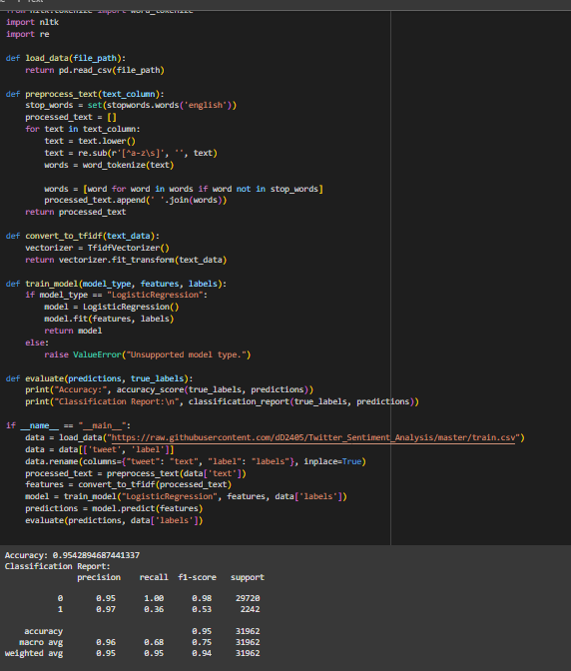

**2. Named Entity Recognition (NER)**

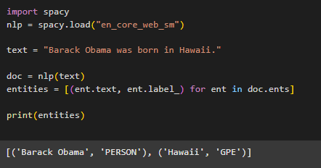

**3. Part-of-Speech (POS) Tagging**

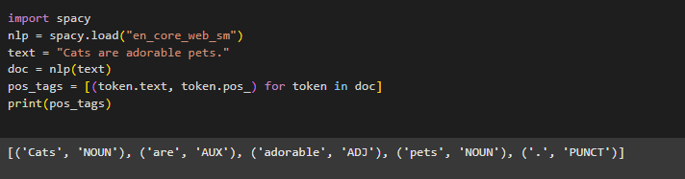

**4. Tokenization**

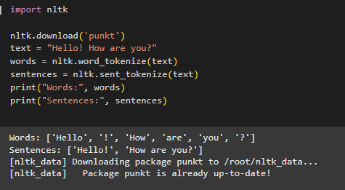

**5. Machine Translation**

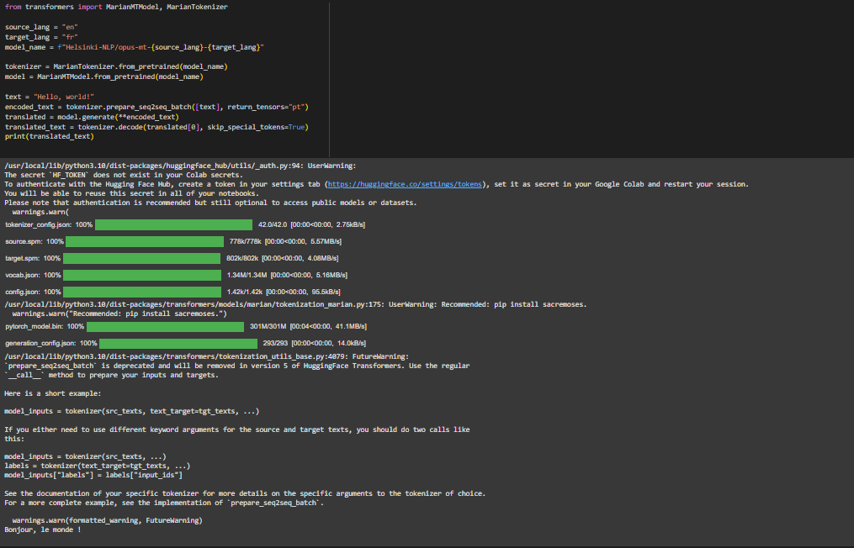

**6. Sentiment Analysis**

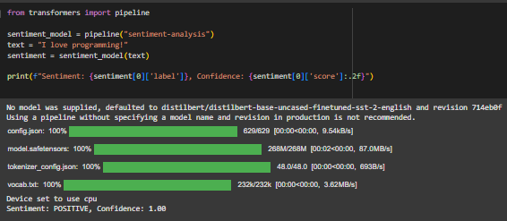

**7. Text Summarization**

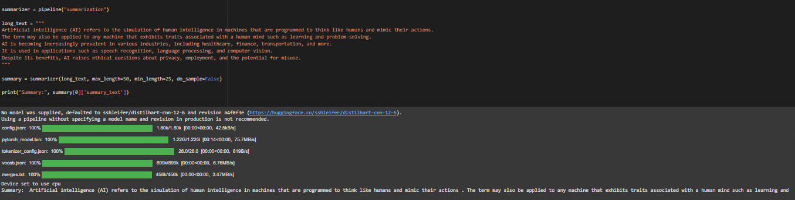

**8. Text Generation**

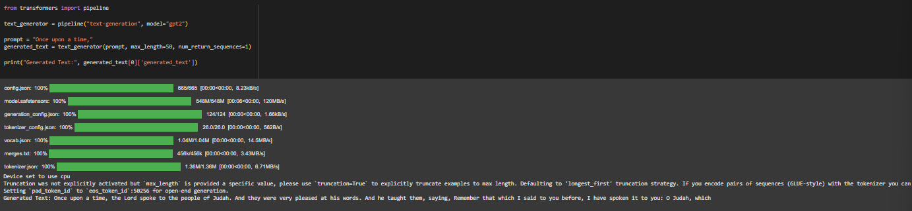

**9. Question Answering**

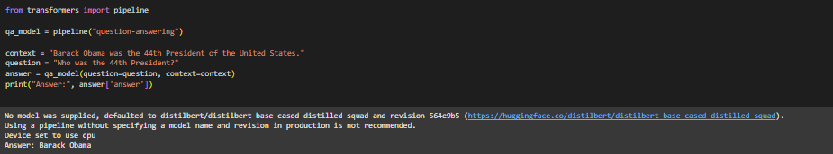

**10. Dependency Parsing**

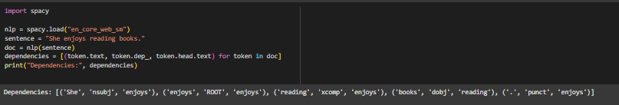

**11. Speech-to-Text**

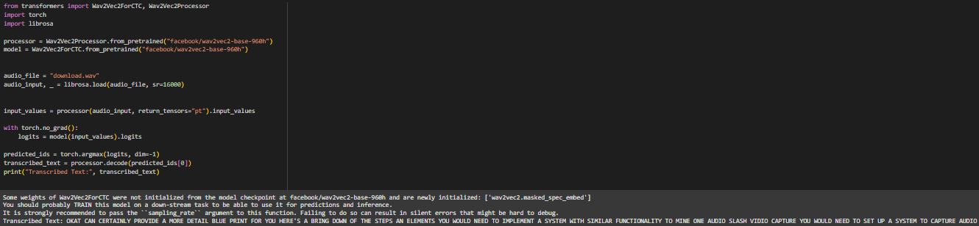

**12. Topic Modeling**

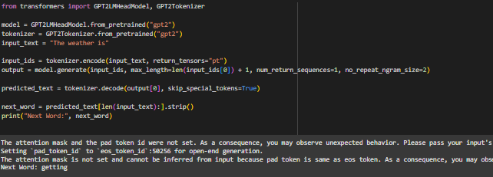

**13. Language Modeling**

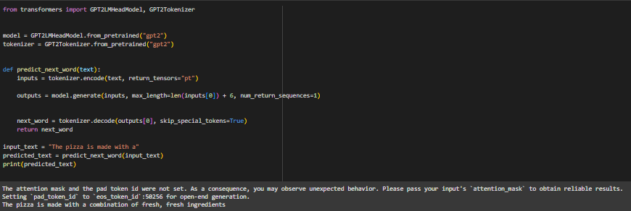

**14. Information Retrieval**

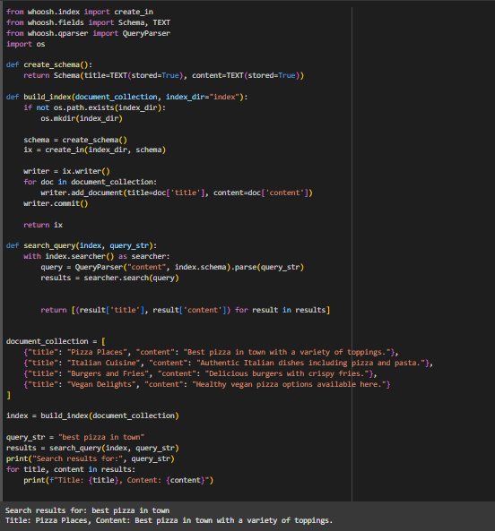

**15. Conversational Agents**

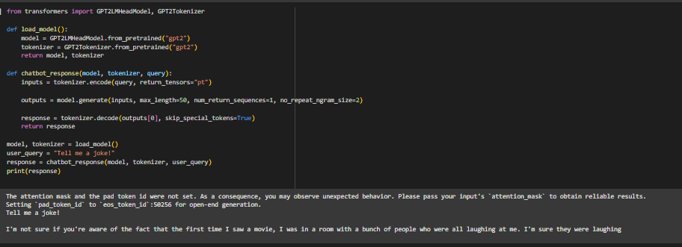

**16. Text Parsing**

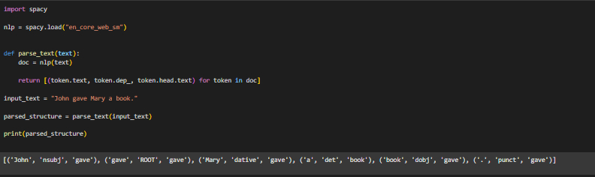

**17. Stemming and Lemmatization**

